- https://www.analyticsvidhya.com/blog/2024/12/hinge-loss-in-machine-learning/
- Hyperplane :
  - A line in 2D, plane in 3D, hence similiarly for the higer dimensions, 4d, 5d the structures are called as hyperplane.
  - Iris dataset is having 4 columns, hence 4 dimensions.
  - The 2 expressions of a line.
  - 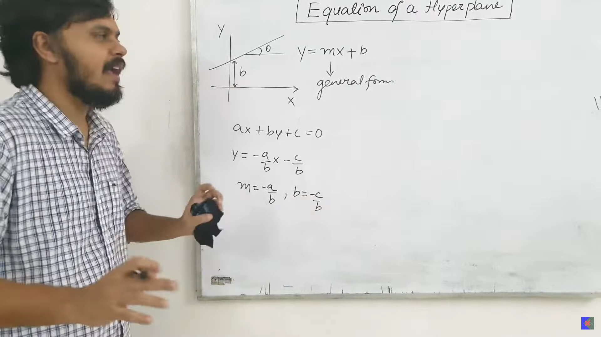
  - 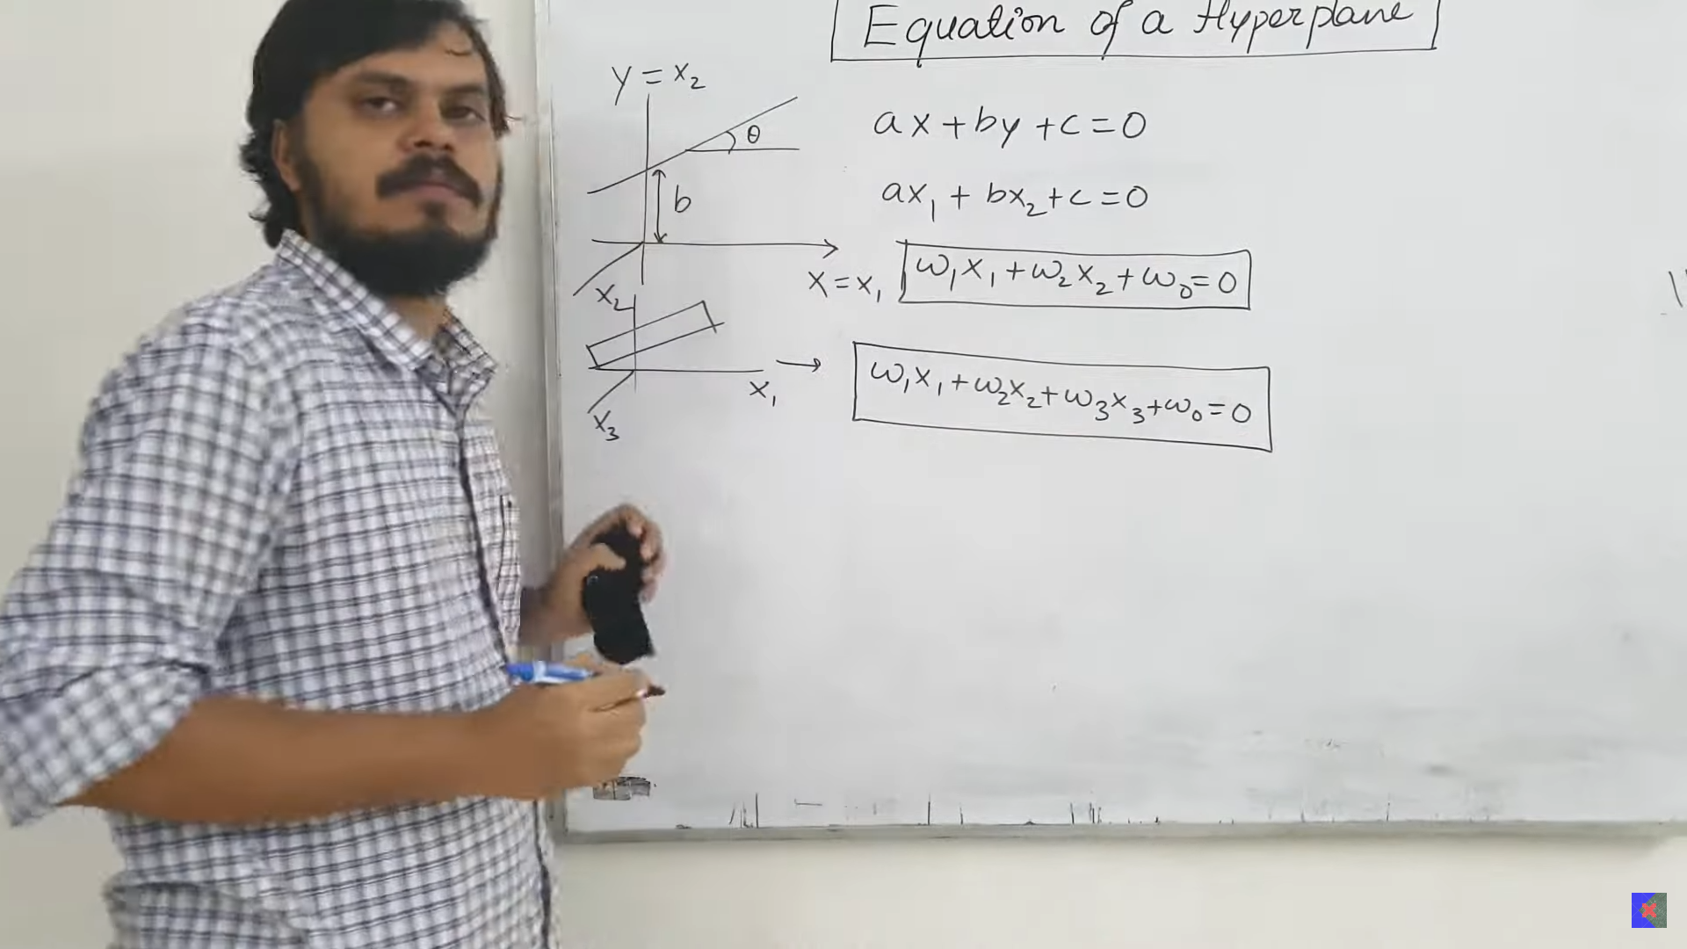
  - The higher dimension hyperplane is represented by pi. Hence the final represntation of the hyperplane is given by:
    - 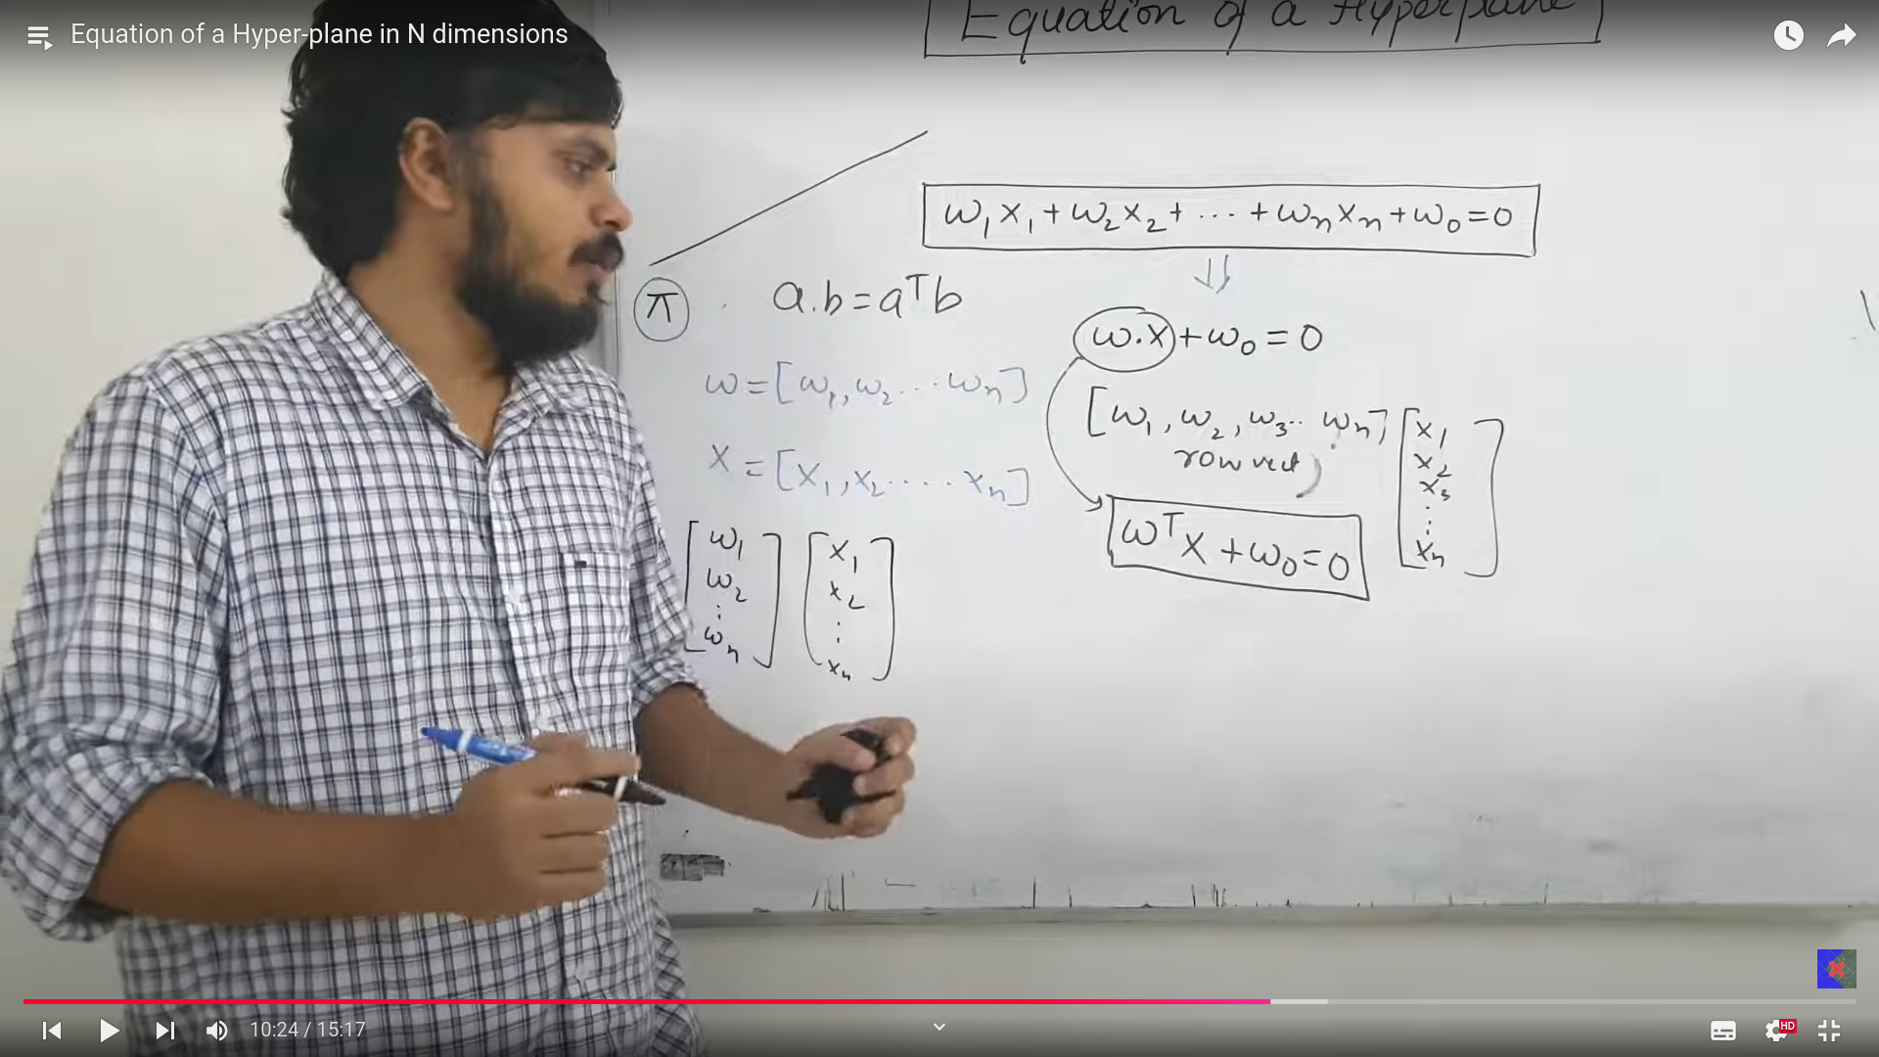
    - If w0 =0, then the hyperplane is going tthrough zero, hence you expand the hyperplane equation.
    - 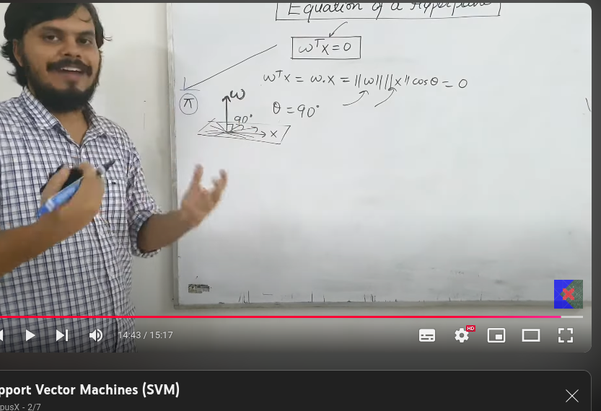
    - The euation of te hyperplane is given by w^T *x = 0. This is the representation of the dot product, hence this dot product is represented by the above equation.
    - w is non zero, x=!0, so then cos theta has to be 0, this is possible only when the angle between w and x is 90 deg. The weight vector is always 90 deg from all the vectors in the planes.

  - Decision rule:
    - We have a decision rule, says, project a point p(x,y) project of the wegit vector, we know that weight vector is perpendicular to all the planes we draw.
    - Question: How to classify that point is positive or negative.
      - Project that point, on w.
      - If that projection is more than some critical condition(diatance), then such point is considered to be positive else it is considered to be negative.
      - Below is the derivation.
      - 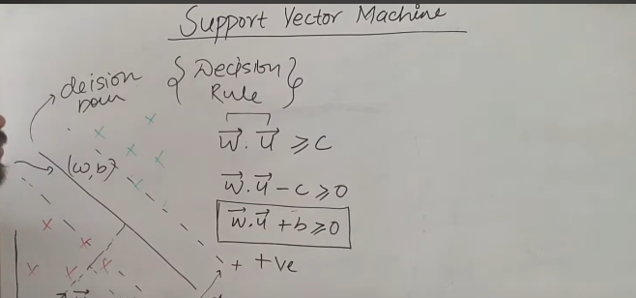
      - Considering the equation of the line to be like: 2x+3y+3 = 0, now projection of point (x,y) on that line is nothing but substituting x and y inn that equation and checking it whether that is greater than the condition or not?? If yes then considered to be poisitve else considered to be negative.

  - 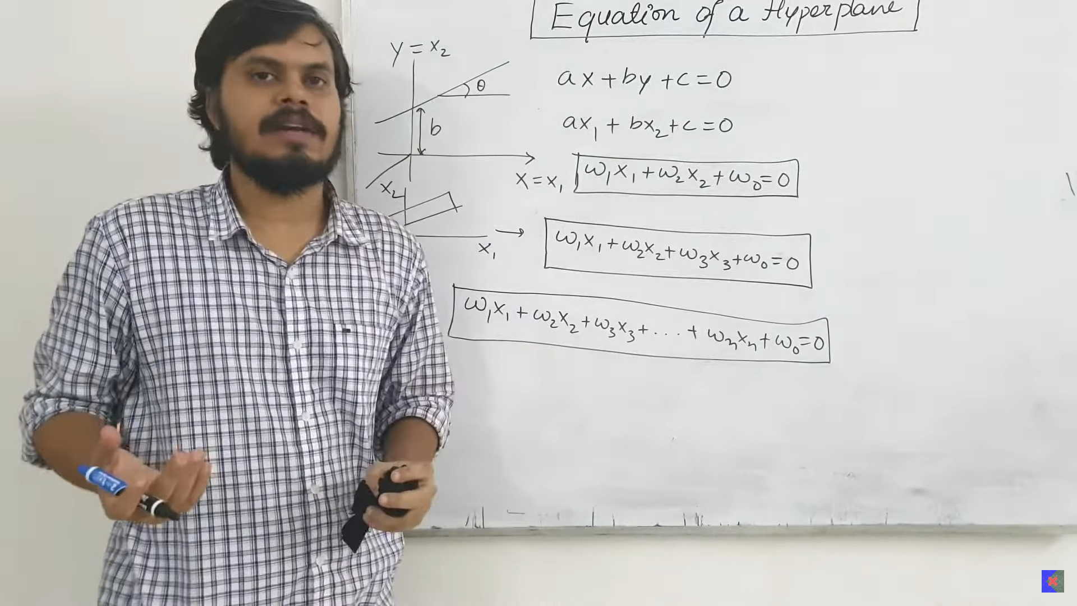
  - 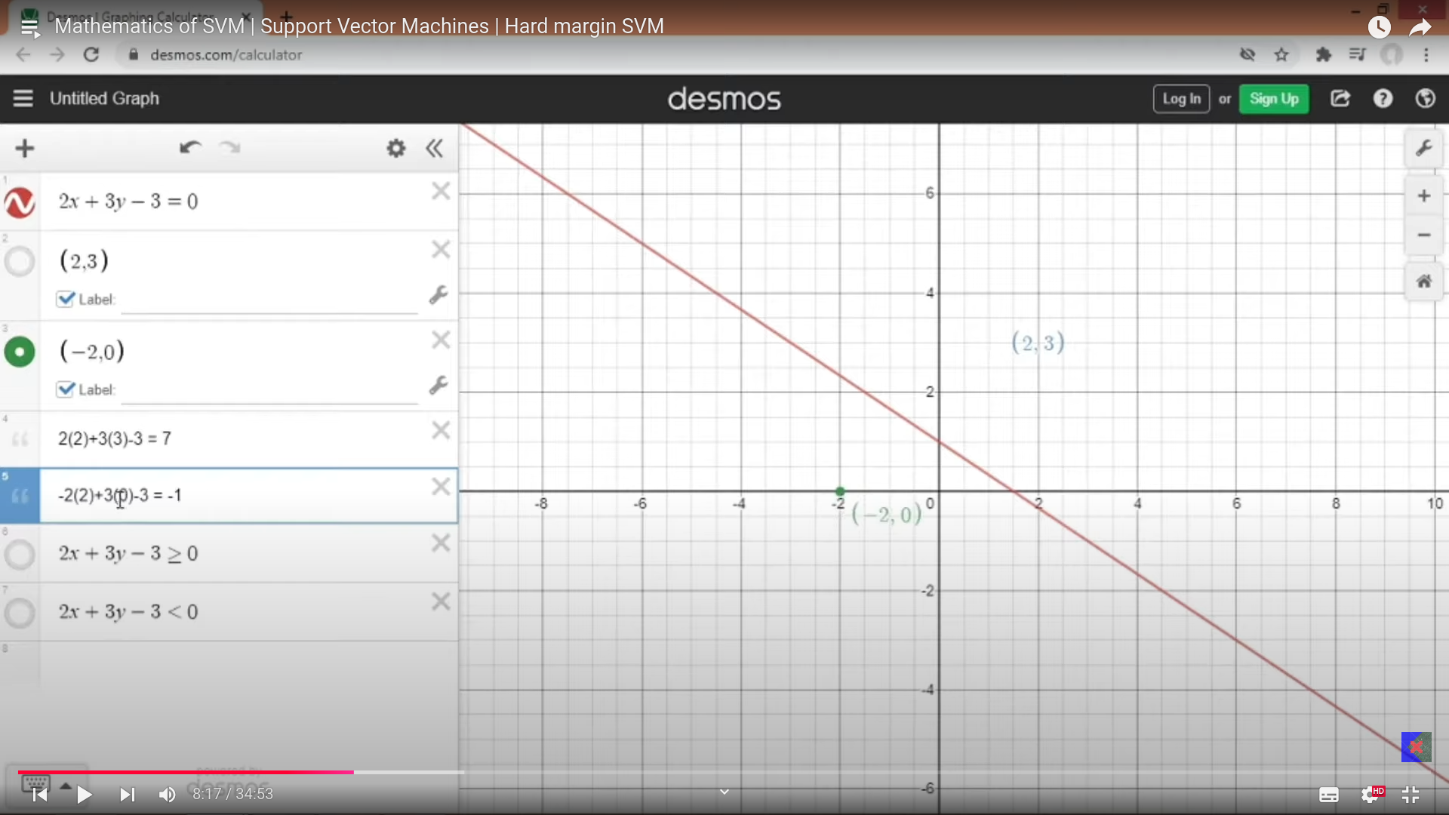
  - 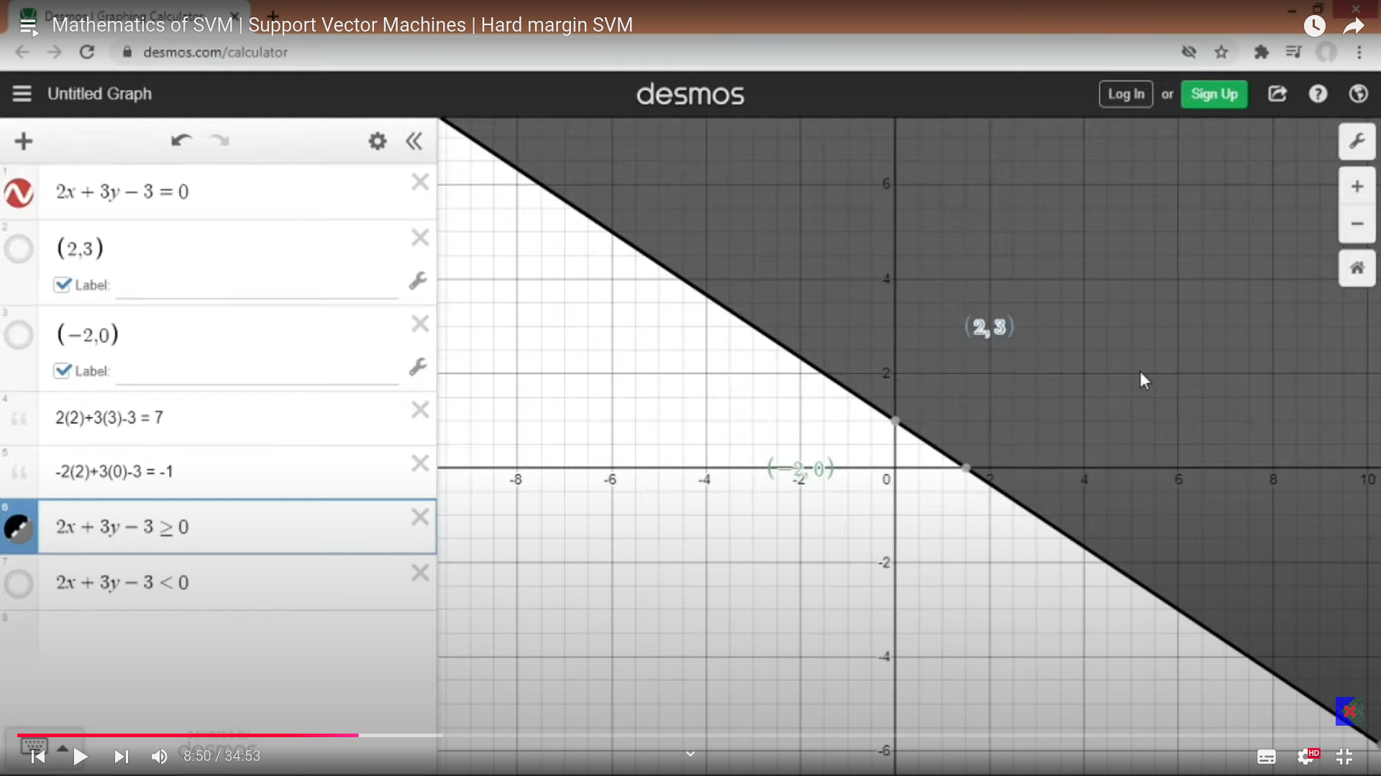
    - Any point falling in the black region is considered for positive.

  - 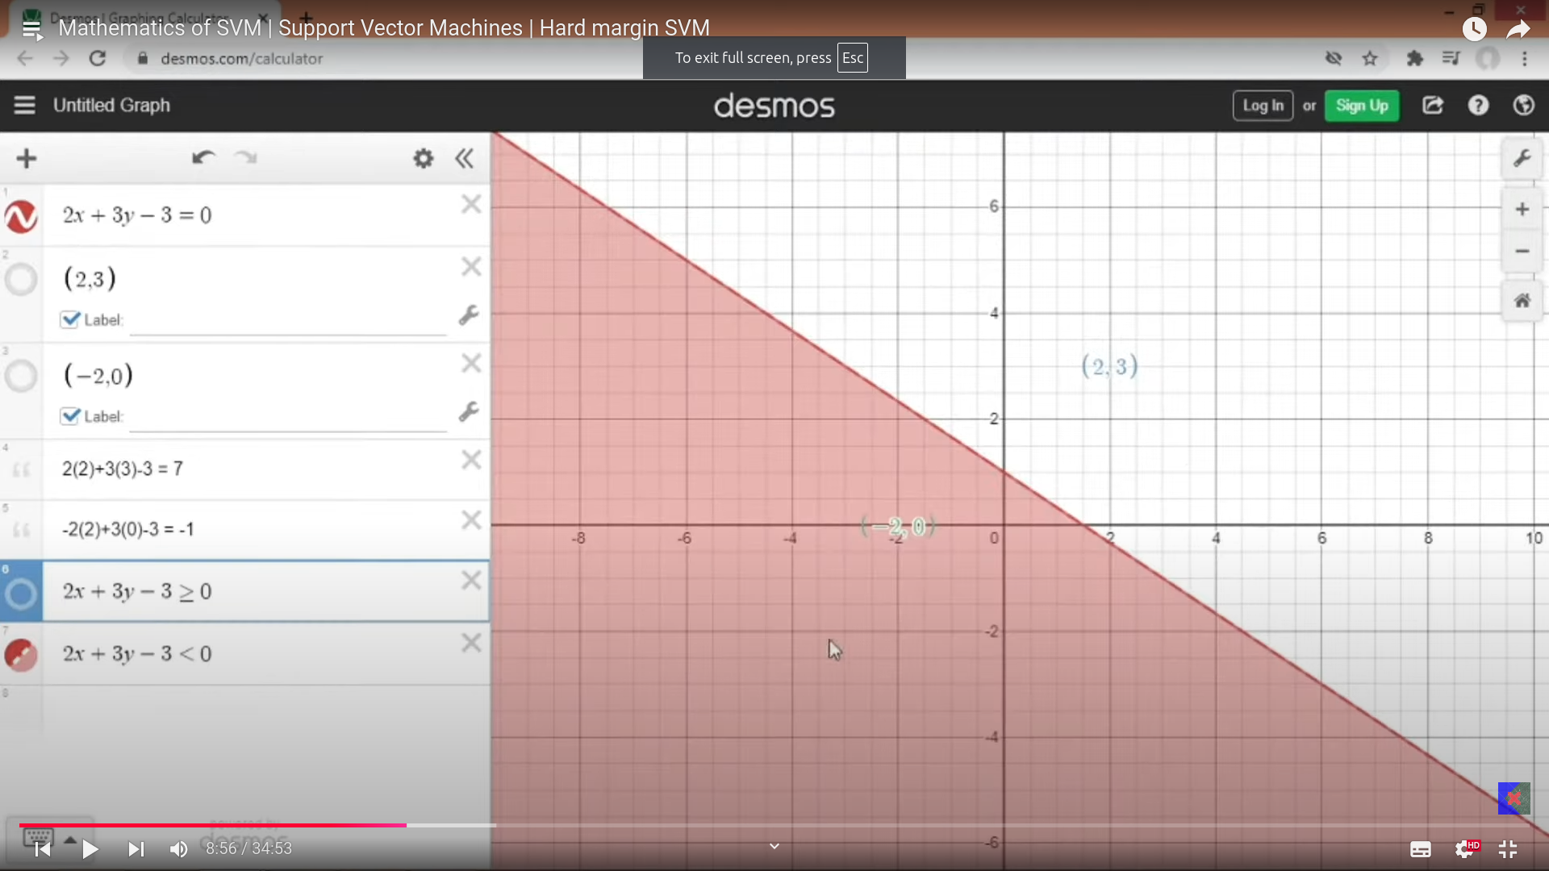
  - Any point in red region is falling , then it is negative point.
  - 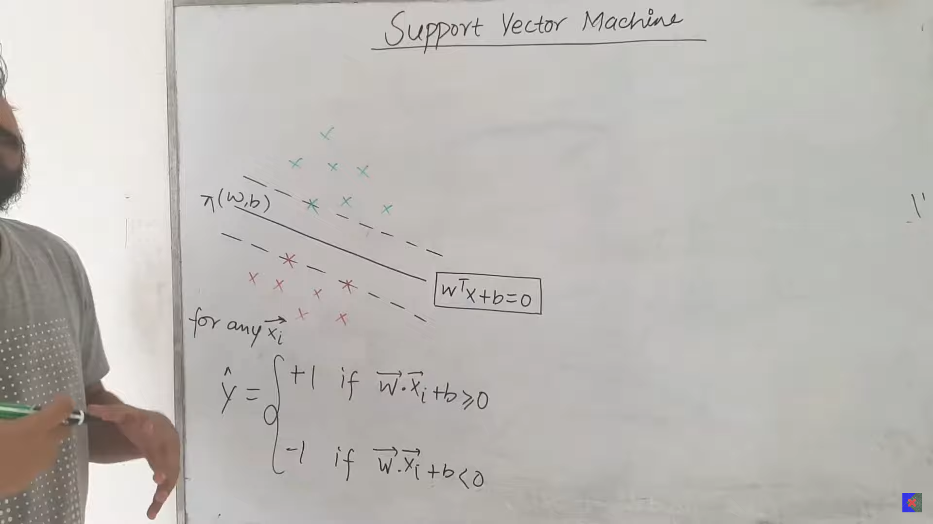
  - The value of w should be such that it has to maximise the distance between the 2 hyperplanes .
  - Assumptions ; W^t *x+b = +1, for positive boundary, W^t *x+b = -1 for negative boundary.
  - Quetions:
    - why exactly +1 and -1, y can’t it be some other number?? like +2, -2 etc. Why the above is necessary?
    - Why the equating has to be equal, like +1 -1, +2 -2 , etc why ??
      - The distance d1, d2 has to be same, so the line in the middle has to be equi distant from the above 2 hyperplanes.
    - -1, +1 why, why can’t it be +25 -25 etc??
      - It does not matter, whether that is +25, -25 etc etc, but has to be equi distant from both the ends. The value +25, etc etc can be equalised b making norm, constants, so we can take anythign for our convienience.
    - Therefore, the line at the middle to be equated to 0 and the lines on both the ends should be equated to some other intercept of equal value with both positives and negatives.

  - 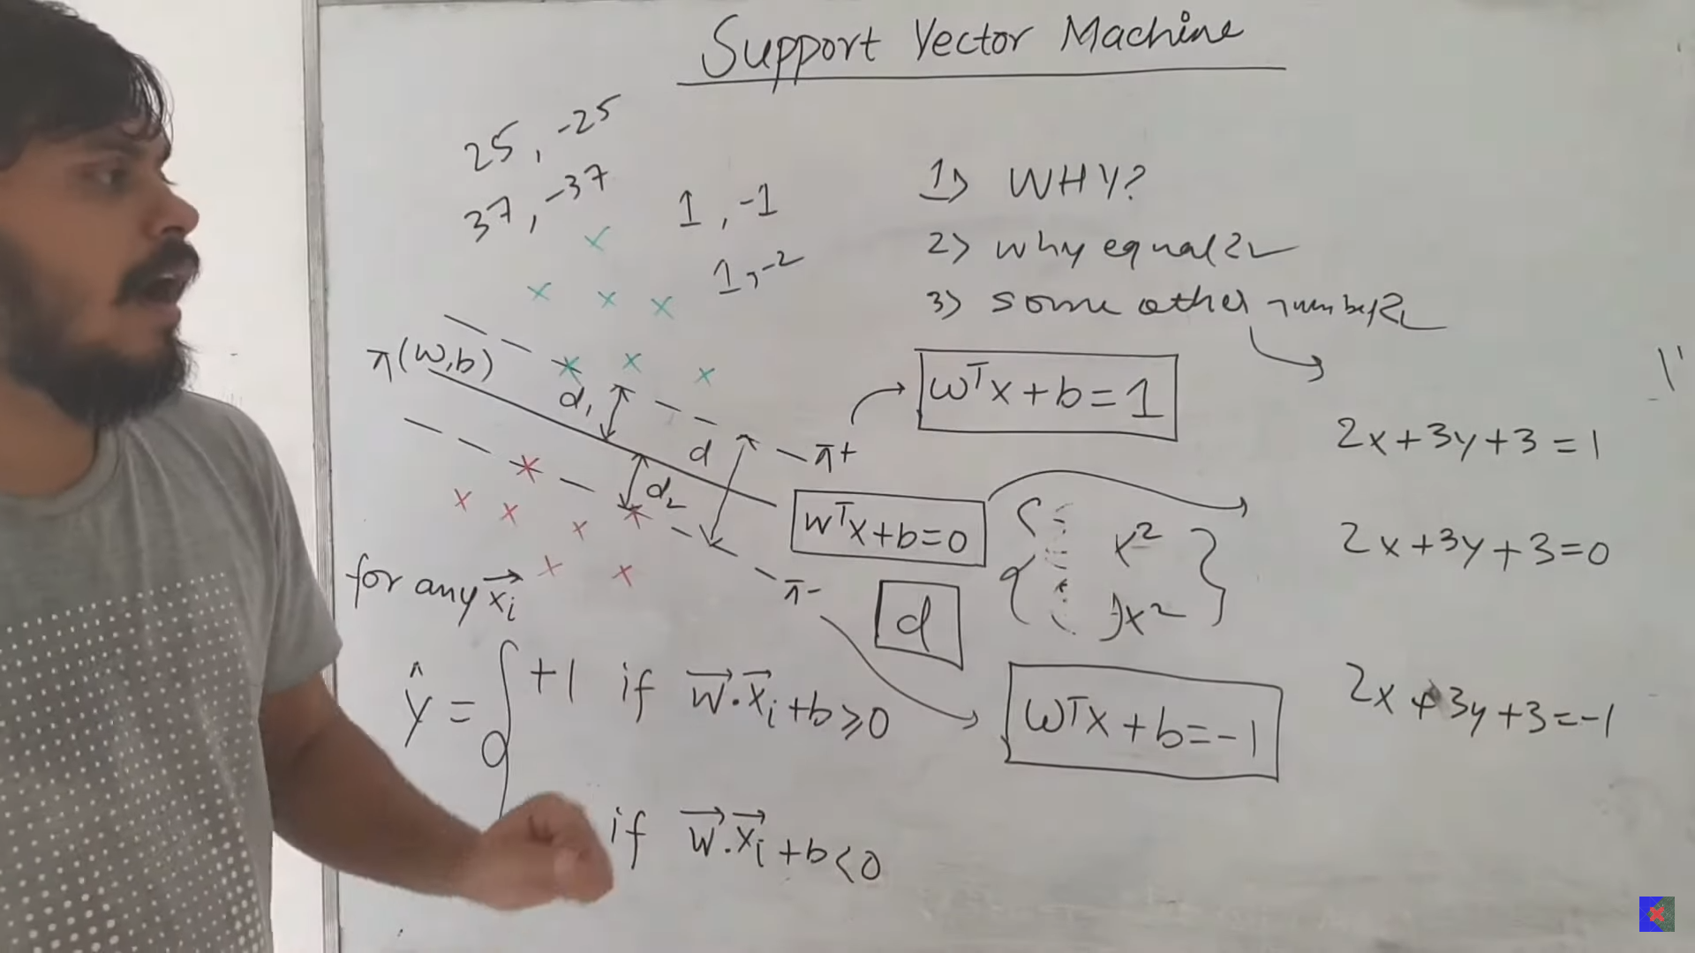
  - 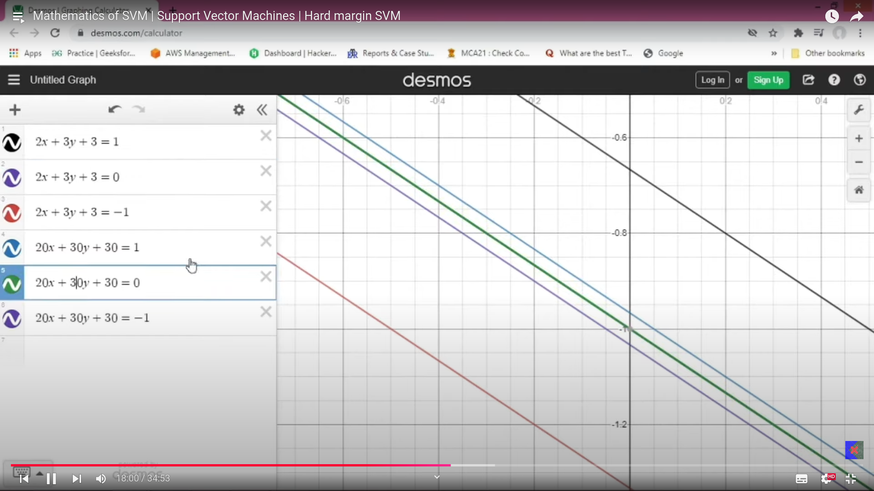
  - The purple and green line is same , with the intercept =0.
  - My multiplied by 10, the lines came very closer. When divide by 10, that is 0.1, then the lines went very far. But in both the scenarios, the intercept remains same.
  - 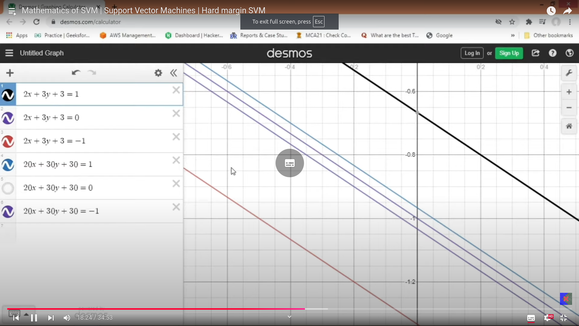
  - 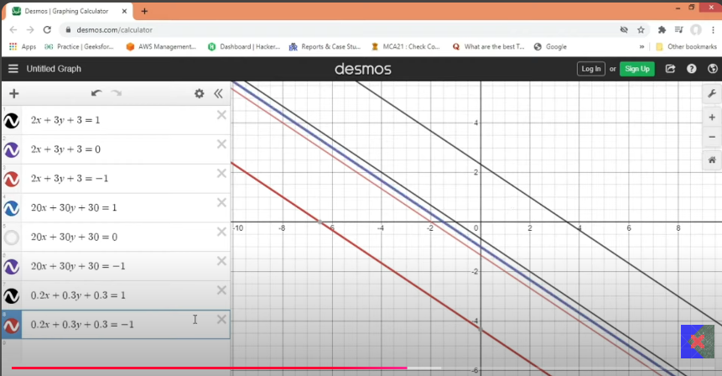
  - 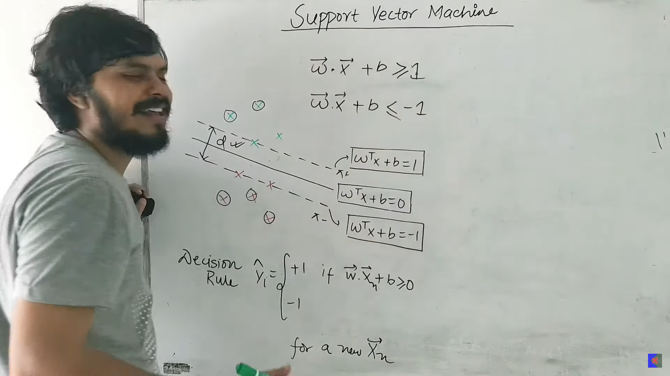
  - Constraints: The green points should not go below the dotted line and the red line should not go above the dotted line.
  - With the above constraints , we need to make the maximum distance d. If the above constrains are wrong then this algorithms will not run.

  - 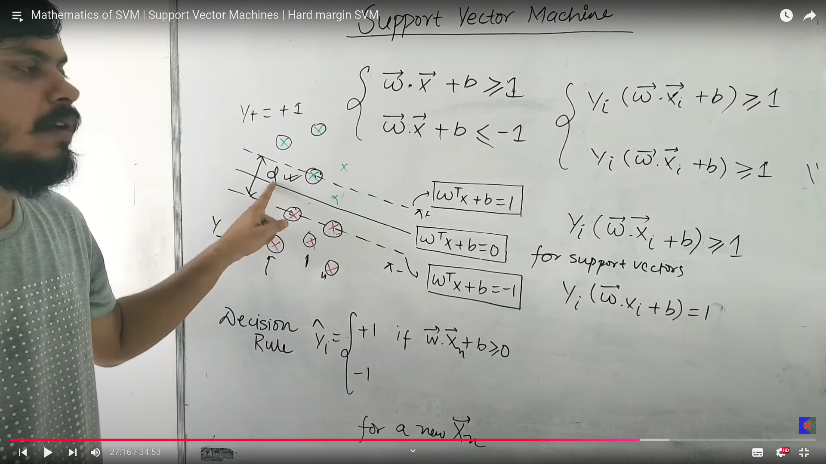

  - 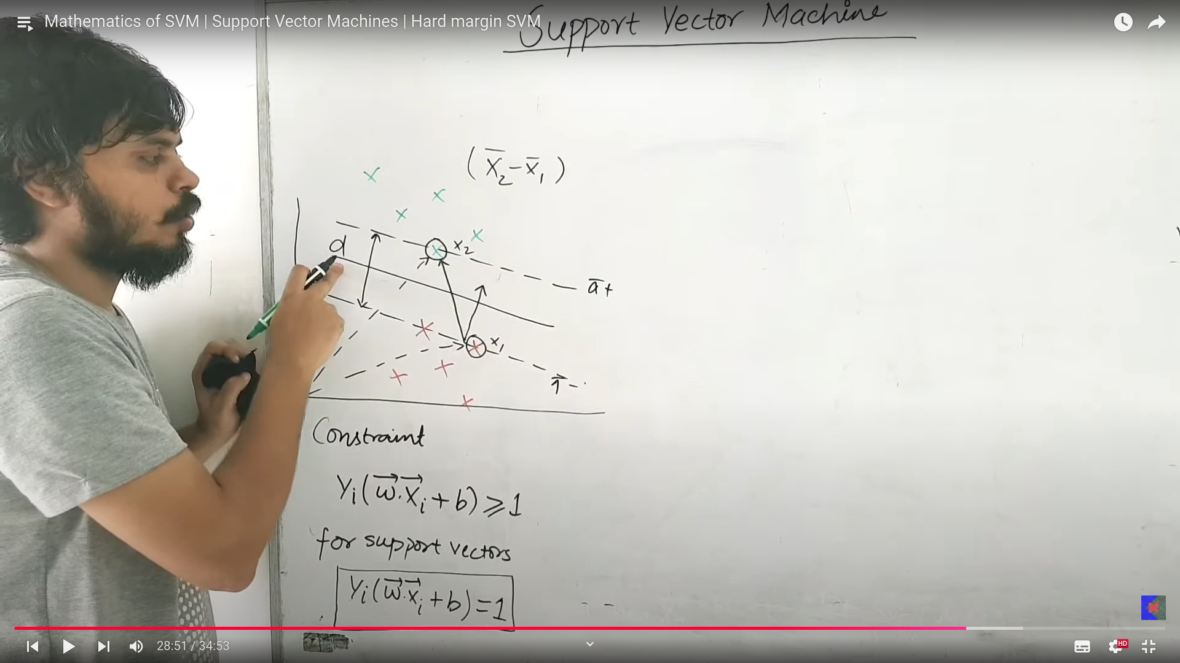
    - Let 2 support vectors be x1 and x2, the distance between these 2 is x2-x1, the vector distance.
    - The projection of this vector x1-x2 on some perpendicular vector, which is w, the perpendicular plane from x1 and x2.
    - which can be given by w^T * (x1-x2) = d, hence this becomes the shortest distance between the vectors.
    - If the w^T *x +b = 10, the distance would be like 20/||w|| .
    - Above is the hard margin SVM.
    - 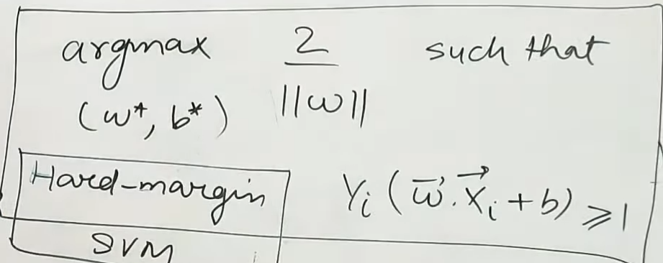
  - Above is what we are expecting to find.

    - 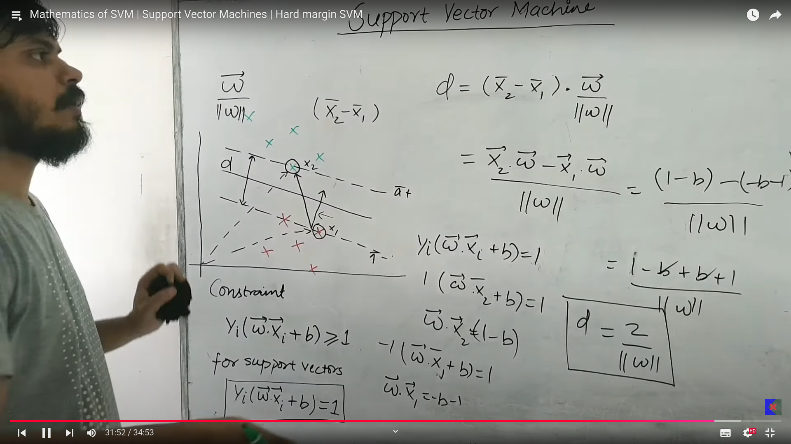

  - 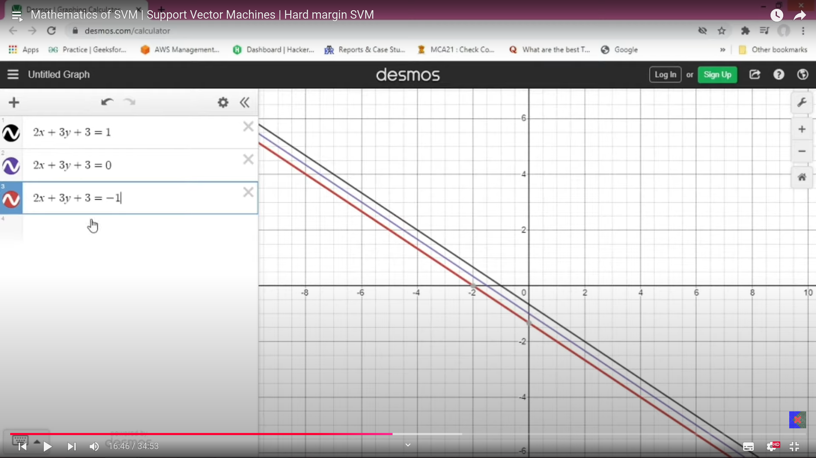

- 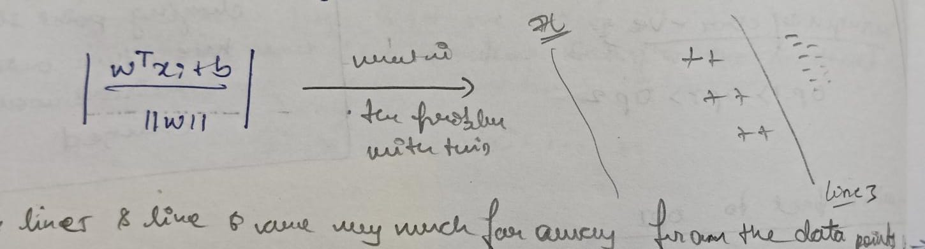
  - The Function which is written above is falsly taking line 7, line and other lines as great seperator which are all very distant from all the points. When summand , the effect can be seen properly.
  - So to overcome it, we use yi*(w^T*xi +b) so the misclassified and correctly classified are cancelled out hence produce the less value, like -0.5,+0.5 etc.
  - The only the line number 3 is with summation or total result is more like 10,15, since the poisitve is given by both sides and no cancellation of distance policy.
  - The above distance what we have got should be maximised. But How??
    - The minimising the distance between the support vector and the marginal line drawn .
- 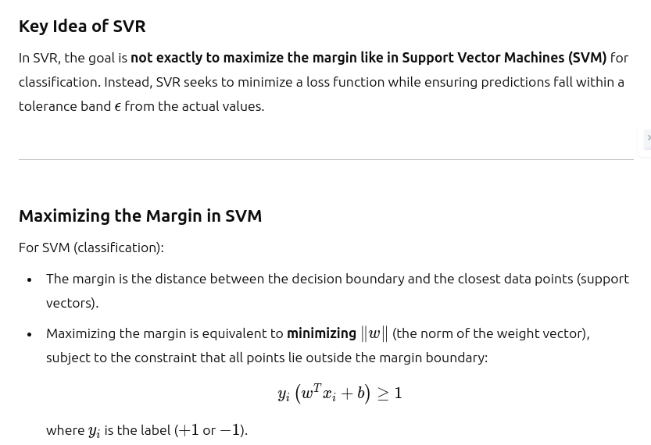
- 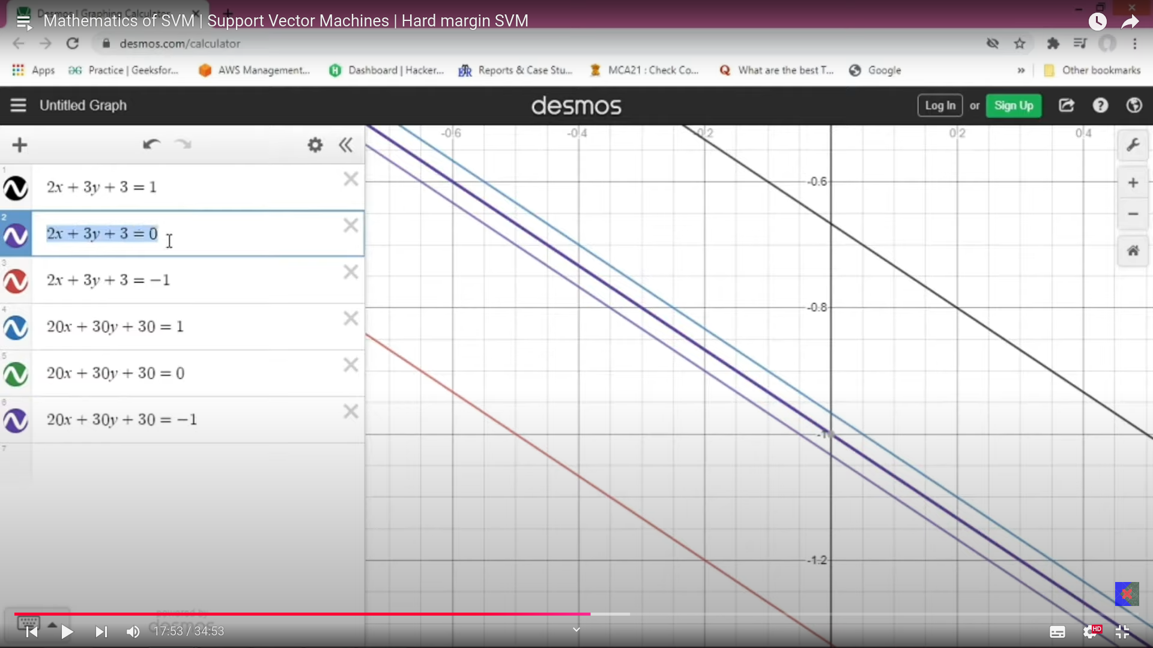
  - The purple line and green line both are same.

- 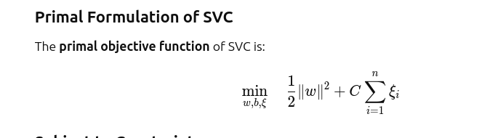
- In Support vector cost function we have 2 types of erros:
  - Marginal error
  - Classification error(C hyper parameter):
    - This can be handled/controlled by the C hyper parameter.
    - C is low:
      - GIve more importance to make more marginal space.
      - Rather than focusing on the classification errors.
      - Margin increased, but there is more lassification errors.
    - C is high: We are telling the model,
      - give imprtance to classification errors, to reduce it.
      - Even though my marginal distance is so small.
      - 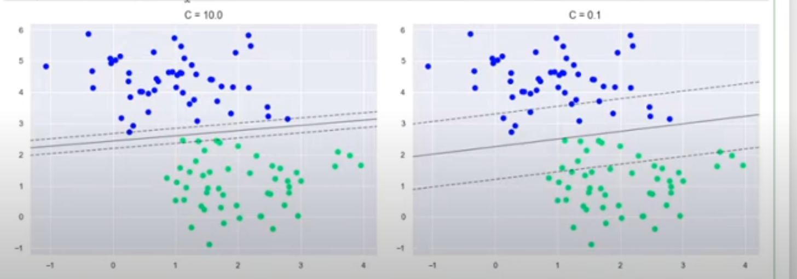
      - When C is high, we are classifying almost perfectley.
    - 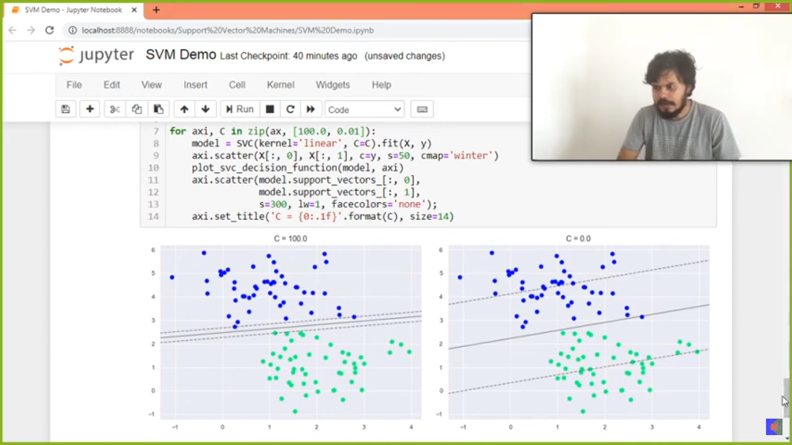

- Soft Margin:
  - If the hard margin is not satisfied the constraints then we must focus on soft margin SVM.
  - 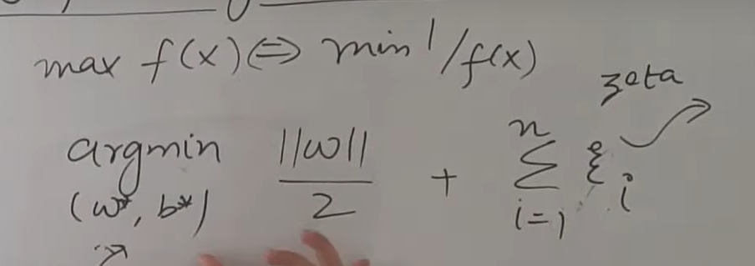
  - 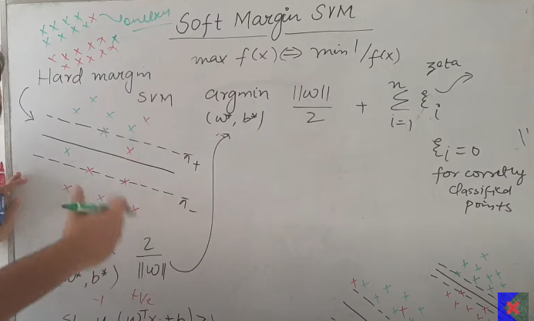
  - 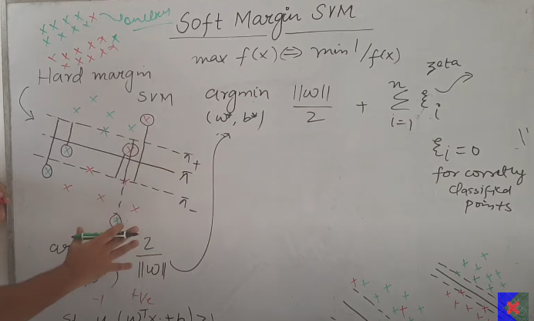

  - For each and every wrongly classified points, we have eta with some value(distance), we need to reduce the eta. Reduce the errors or minimize the errors.
  - 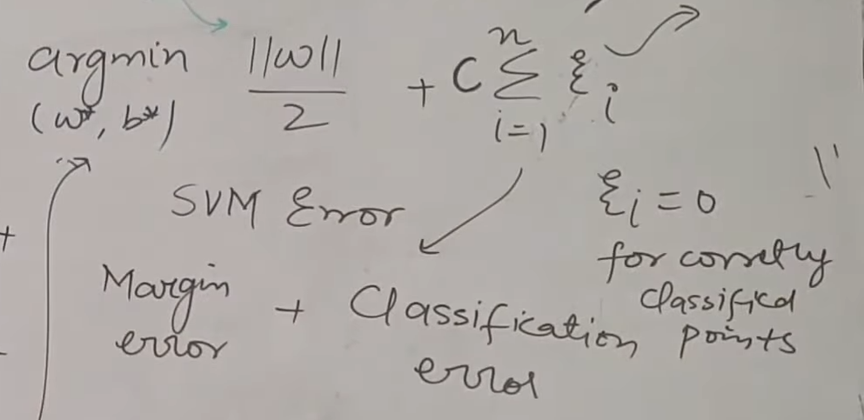
  - The margin and marginal error is inversley proportional to each other.
    - As the margin increases the marginal error decresases and when marginal error decresases, the margin increases.
    - 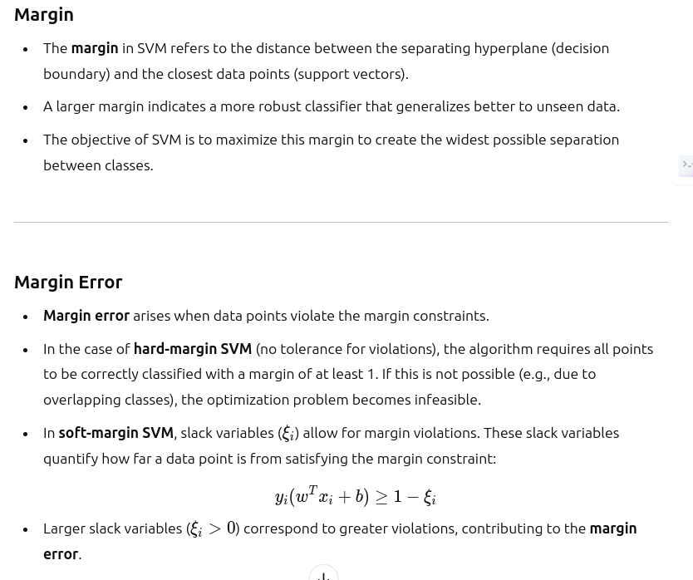

    - 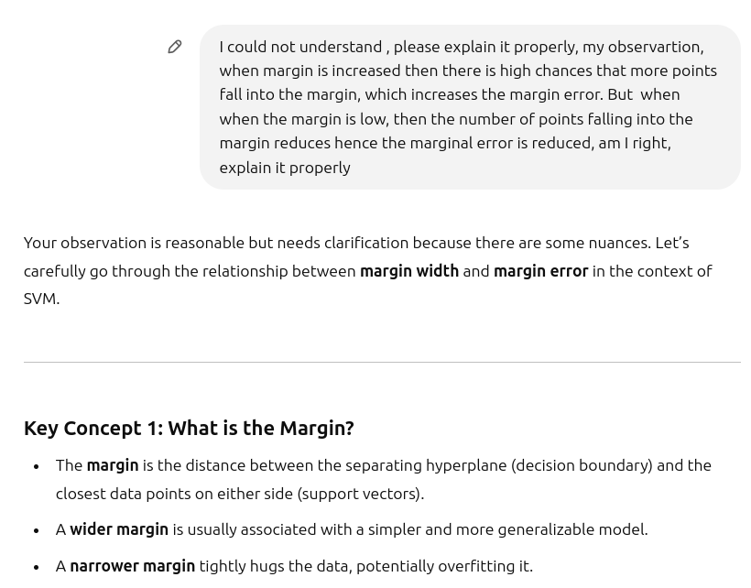
W and margin distance realtionships
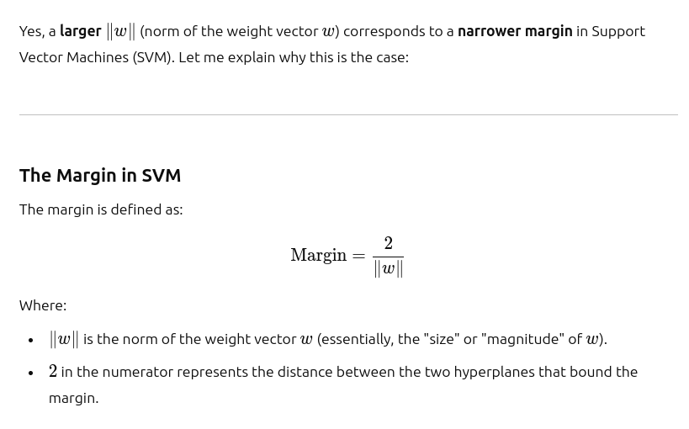
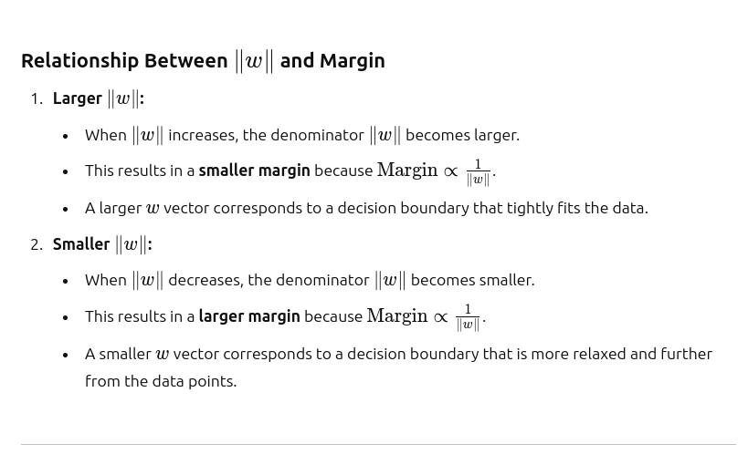
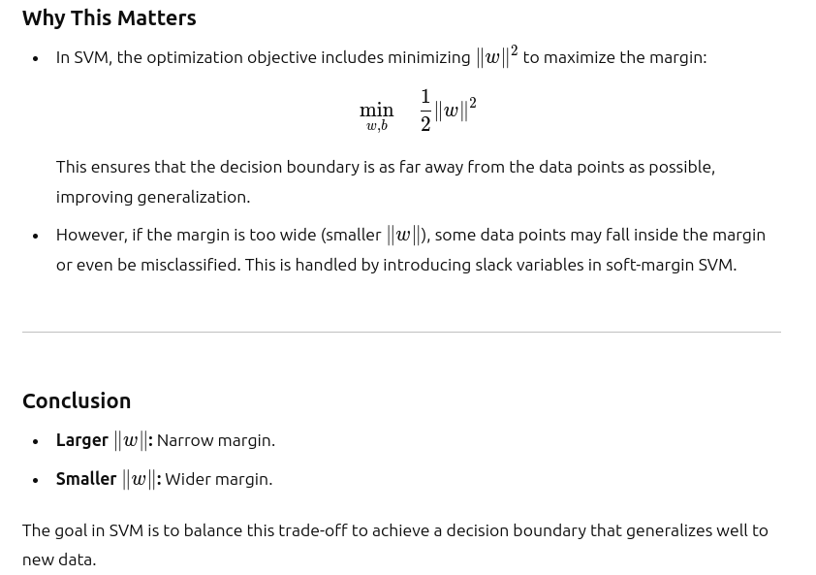
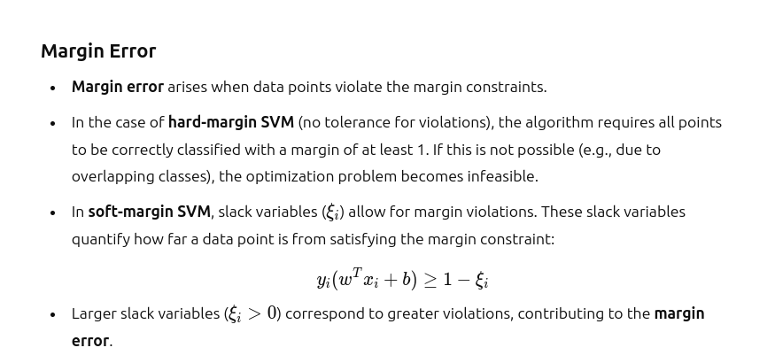
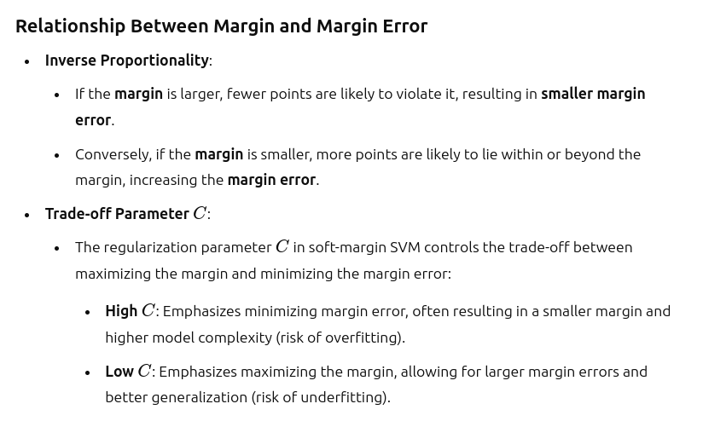
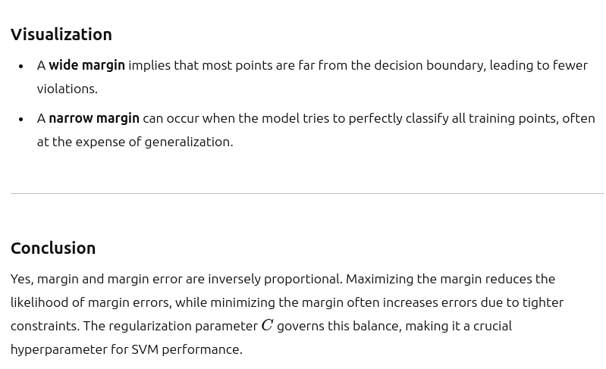
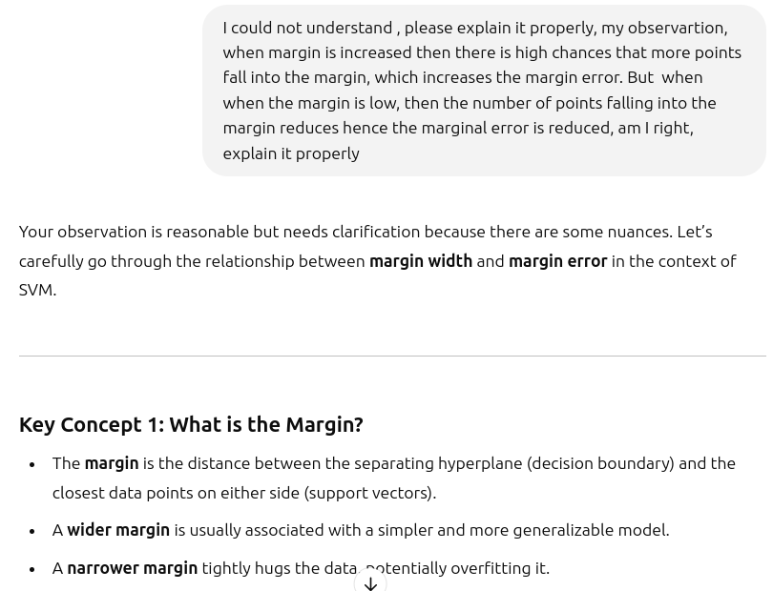
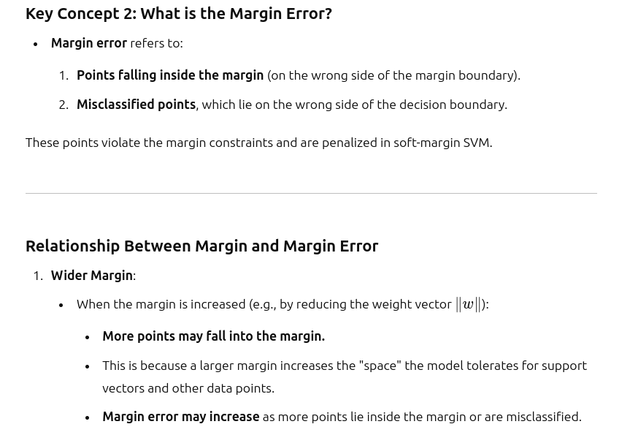
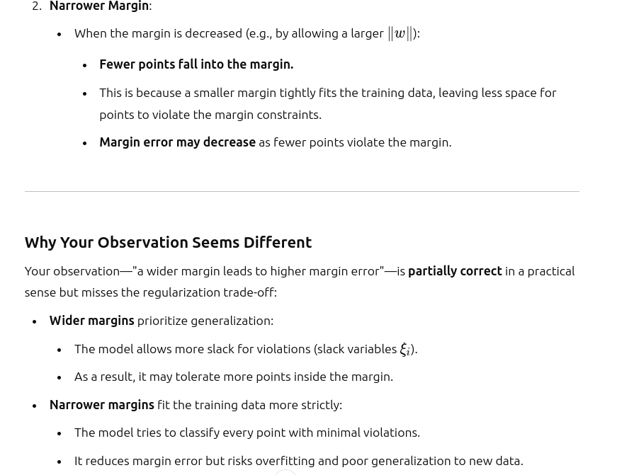
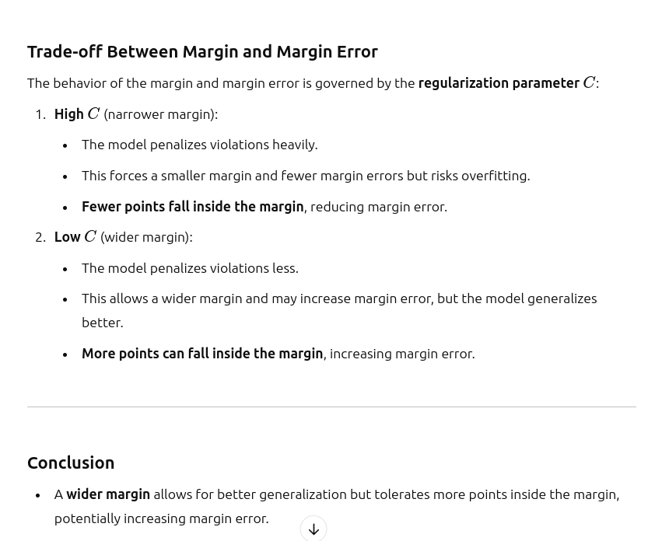
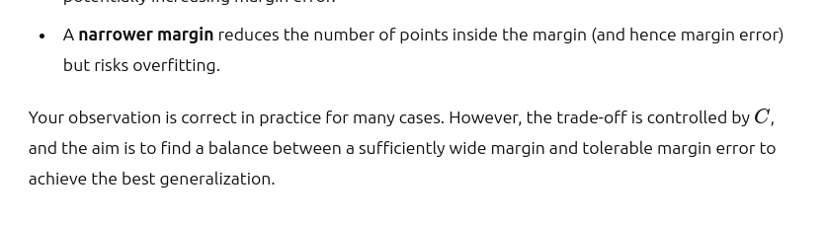

  - s

- s

